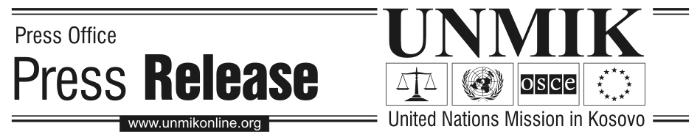
UNMIK/PR/1624
– UNMIK Countdown #6 –
Wednesday, 20 December 2006

UN Volunteers bring experience to Kosovo

PRISTINA – UN Volunteers participation in UNMIK dates back to the beginning of the mission in June 1999 when some 200 UN Volunteers supported the mission in humanitarian work, organizing food deliveries, providing medical care and setting up temporary shelter for thousands of refugees returning to Kosovo. In addition to this, 400 UN Volunteers helped to register approximately one million people in Kosovo for the municipal elections in October 2000. After that, UN Volunteers started to assist elected local authorities within the newly formed institutions. Today, 147 UN Volunteers from 59 different countries are serving in the Department of Justice (DOJ), Department of Civil Administration (DCA), Kosovo Police Service (KPS), UNMIK Division of Administration (DOA) and the Office of the SRSG.

“Over the last seven years in Kosovo, UN Volunteers have been working in many different areas. They have helped to establish a functioning travel document system for Kosovo residents and they have worked closely with local youth to promote peace through sports. UN Volunteer Medical Doctors, Legal Officers, Psychologists, Finance Officers and Civil Affairs Officers, among others, are an asset for UNMIK and help in fulfilling its mandate,” said Stuart Moran, Programme Manager of the UNMIK UN Volunteers Programme in Kosovo.

The average UN Volunteer in Kosovo is around 40 years old, has a Masters Degree and a minimum of five years working experience in his/her professional field. The UN Volunteers work alongside the professional national and international UN staff members in different spheres of UNMIK’s activities.

In 1970, the UN Volunteers programme was created by the UN General Assembly to serve as an operational partner in development cooperation at the request of UN member states. In promoting peace and solidarity, the UN Volunteers Programme in 1992 started to support the work of the UN Department of Peacekeeping Operations (DPKO) by operating in post-conflict areas. Since then, more than 7,000 UN Volunteers have served in different peacekeeping operations all over the world.

The UN Volunteers Programme is administered by the United Nations Development Programme (UNDP) and works through UNDP’s country offices around the world. Since its start in 1970, over 30,000 UN Volunteers representing 160 nationalities have worked in 140 countries.

For further information, contact Public Information Officer Hanna Snarberg:
Tel: +381 (0)38 504 604 ext: 5790, Mobile: +377 (0)44 151 858, E-mail: snarberg@un.org

Note to Editors: With UNMIK in its final phase before status resolution, the Division of Public Information senses an increasing historical focus by local and international media on Kosovo. Therefore, in this special series of weekly press releases we offer news and information about the UN Mission in Kosovo during the past seven years. The press releases seek to provide useful information about UNMIK, including quotes from officials as well as photos and web links.

