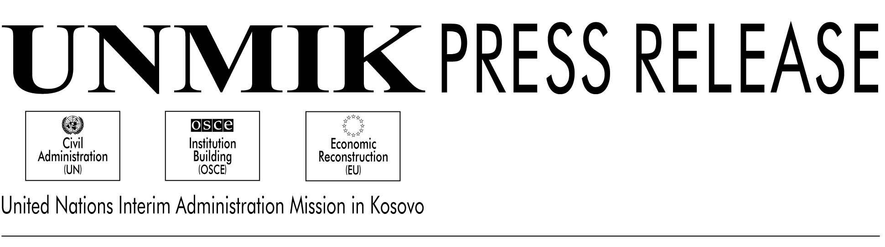

UNMIK/PR/395

18 October 2000

KTC Briefed by the Housing and Property Claims Commission

PRISTINA--- Today the international commissioner of the Housing and Property Claims Commission, Mr. Alan Dodson briefed the Kosovo Transitional Council on the activities of his agency.

The commission’s task is to handle claims of residential property such as houses and apartments throughout Kosovo. Mr. Dodson informed the members of the KTC that they are dealing with three types of claims: cases in which people lost their apartments because of discrimination during the last ten years; cases where discriminatory laws failed to reflect the rightful owner of the residence; and cases in which people lost possession of their property after the conflict last year.

The Housing and Property Claims Commission consists of two international and one local commissioner. Its administrative body, the Housing and Property Directorate, is made up of local and international employees, most of them lawyers.

The claims must be lodged to the Directorate by December 2001, and only claims since 23 March 1989 will be dealt with. Mr. Dodson said that so far an office has opened in Pristina, and one mobile team is for the time being operating in Gracanica. Two regional offices in Mitrovica and Gnjilane will also open as soon as refurbishment of the facilities and recruitment of staff is finalized.

Responding to these issues, some of the Kosovo Serb representatives said that there was a very important work to be done in this regard, but that the regulation on these issues is not specific enough and therefore gives too much room for interpretation to the commission. Furthermore, the one of the representatives feared that this regulation would make a return of the rightful owners difficult.

Mr. Dodson replied by saying that they needed some flexibility at such an early stage. A too long delay and a lack of enforcing decisions made were the worst which could happen, and he asked for the co-operation of law enforcement agencies to implement the commission’s decisions.The process will be reviewed and if necessary there are possibilities to make amendments to the regulation, Mr. Dodson added.

There will be a freeze of all property transactions in which the owner changed after 23 October 1989 effective from when the regulation comes into force.

In other business, both SRSG Dr. Bernard Kouchner told briefly about his visit to Croatia where he had talks with the Croatian president. Together with the head of OSCE, Daan

Everts he urged the Kosovo Albanian members of the KTC to abstain from using the Albanian flag

during election day. They both understood the emotional importance the flag had for the population, but emphasized that this election was lead by the international community, which had to be neutral, democratic and transparent. It is extremely important that these elections are beyond criticism, Mr. Everts stated.
Several of the Kosovo Albanian representatives responded to this by saying that the flag was a very important symbol for national identity. They felt the need to have meetings to find some sort of compromise.

DSRSG Daan Everts then gave an update on the OSCE’s work before the municipal election, and was very pleased with the process so far. Some of the members had complaints against the media and felt that some political parties didn’t get the coverage they were entitled to. Mr. Everts responded by saying that he did not control the press, and urged those who felt this way to file their complaints with the Elections and Appeals Committee.

