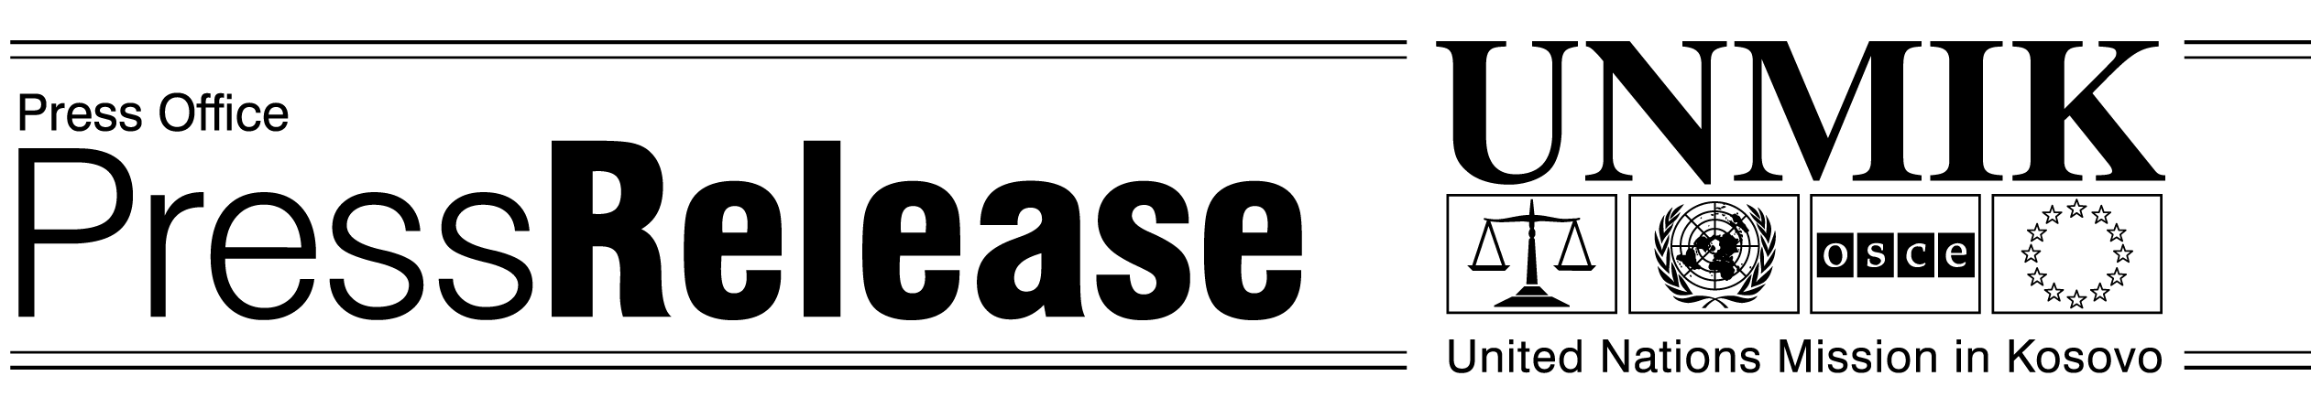
UNMIK/PR/765
Wednesday, 26 June 2002

UNMIK Welcomes FYROM Decision

PRISTINA – UNMIK welcomes the decision of the FYROM Government to abolish visas for the holders of the UNMIK Travel Document. The decision comes into force from today.

The decision is the result of discussions between UNMIK and FYROM, aimed at easing movement of people between Kosovo and FYROM. It will help those who are seeking visas from foreign embassies based in Skopje, medical help or those who want to meet relatives. This decision will greatly help Kosovans to travel.

