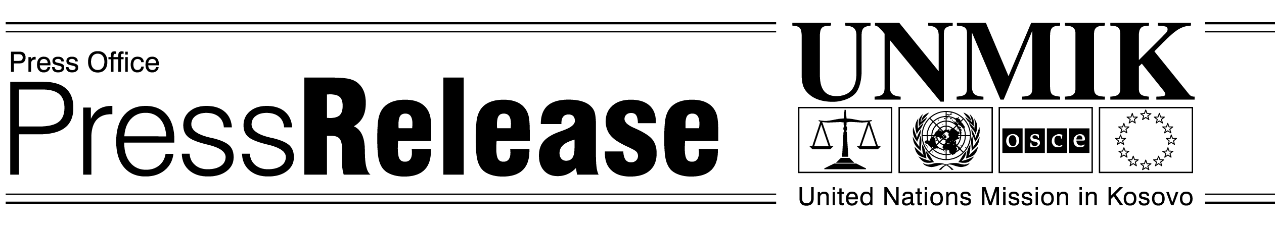
UNMIK/PR/930
Friday March 7, 2003

SRSG announces transfer of responsibilities to government through Transfer Council

Pristina – SRSG Michael Steiner announced today, in a joint press conference with Kosovo Prime Minister Bajram Rexhepi, the establishment of the Transfer Council as a vehicle to begin the transfer of substantial responsibilities from UNMIK to the Institutions of Provisional Self Government.

The Transfer Council will decide upon the means and timetable to implement, coordinate, oversee and review the transfer process.

“One year ago the Government was formed,” said SRSG Michael Steiner. “Now UNMIK is moving to strengthen Kosovo institutions. UNMIK and the Government have agreed: substantial responsibilities will be transferred in a phased process throughout this year.”

In line with UNSCR 1244 and UNMIK’s mandate to promote the establishment, pending a final settlement, of substantial autonomy and self-government in Kosovo, to ensure conditions for a peaceful and normal life for all inhabitants of Kosovo, and in recognition of progress made by the Provisonal Institutions so far, UNMIK is now moving to strengthen Kosovo institutions.

“The process will work within 1244 and Constitutional Framework – my mandate,” said SRSG Michael Steiner. “To more easily do this we are Establishing the Transfer Council. It will be co-chaired by Prime Minister Rexhepi and myself. Other senior officials will also join, on a rotating basis, depending on the agenda. Minority communities will be represented on Council.”

“With the Government’s new responsibilities also the responsibility for fulfilling standards will increase,” said SRSG Michael Steiner. “Power means responsibility. Both UNMIK and the Provisional Institutions of Self-Government shall monitor progress towards these standards.”

SRSG Michael Steiner also explained that the new responsibilities would also raise the stakes. “Kosovo’s institutions will have greater powers and face greater sanctions if they abuse those powers,” he said.

“I’m very happy today because we created the Council, and the more authorities you have, the more responsibilities you bear. I hope we are on the path to be more efficient, in the interest of all Kosovo citizens”, said Steiner.

UNMIK shall retain final authority as set out in 1244 and the Constitutional Framework. UNMIK will increase its focus on its core responsibilitites, in particular the protection of minority rights, the rule of law and security and external relations. Monitoring violations of 1244 and Constitutional Framework will increase. UNMIK will get tougher on violations of minority rights.

The Council will, however, discuss increasing Kosovan input in reserved areas such as more senior Kosovans in the BPK and the utilities.

Except in cases where 1244 and the constitutional Framework have been breached, UNMIK will not overrule the Provisional Institutions on matters within their competence. With this exception, decisions taken by the Provisional Institutions should not be evaluated by UNMIK, but by the Kosovans themselves.

First meeting of Council March 26.

