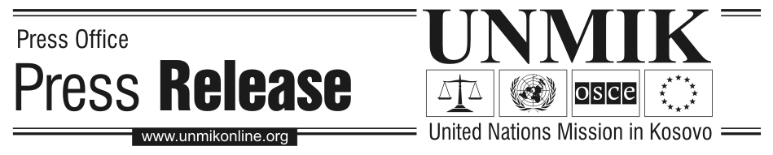

UNMIK/PR/1307
Tuesday, 25 January 2005

Legislation for mining sector comes into force

PRISTINA – The PDSRSG Larry Rossin signed and promulgated last Friday UNMIK Regulation No. 2005/2 on the Establishment of the Independent Commission for Mines and Minerals and Regulation No.2005/3 on Mines and Minerals in Kosovo.

A draft mining law, which had been prepared jointly by the Government and UNMIK, could not be completed by the Assembly due to time constraints prior to the Kosovo elections in October 2004. The Government therefore approached UNMIK and requested that the necessary legislation for the mining sector be prepared and promulgated by UNMIK, pending adoption of legislation by the Assembly for the mining sector, which will constitute the definitive legislative framework for the mining sector in Kosovo.

Together, the two Regulations establish a complete legislative framework for mining in Kosovo, consisting of a comprehensive new and complete mining law that conforms to industry standards – the Regulation on Mines and Minerals and Kosovo – and a Regulation which establishes the Independent Commission on Mines and Minerals to act as the regulatory body for application of the mining law and regulating exploration and exploitation of minerals in Kosovo.

The new legislative framework is necessary inter alia to address concerns voiced by international investors regarding the urgent need to enhance the inadequate existing legal framework for Kosovo’s mines and minerals sector. It establishes a new system of licenses, permits and authorisations that makes it possible to issue new mining licenses and permits. This will not only greatly facilitate privatisation of socially-owned mining enterprises but also attract new investments into the mining sector of Kosovo.

Both regulations have become effective as of the date of signature [21 January 2005].

