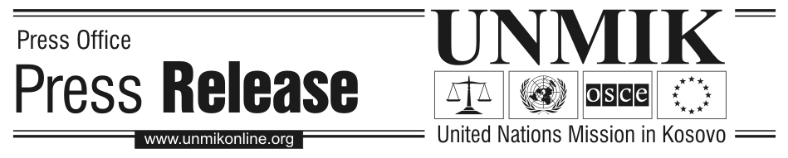

UNMIK/PR/1352
Friday, 29 April 2005

SRSG Promulgates New Regulation on Pensions in Kosovo

PRISTINA – SRSG Søren Jessen-Petersen has promulgated today UNMIK Regulation on Pensions in Kosovo (UNMIK Regulation No. 2005/20) amending UNMIK Regulation No. 2001/35.

PDSRSG Larry Rossin, who signed the regulation for the SRSG, said: “This is a positive step, because the amendments guarantee a transparent process for selecting and appointing the members of the board of the Kosovo Pension Savings Trust.”

The new regulation allows for the establishment of a Committee for the selection of the Board members to the Governing Board of the Kosovo Pension Savings Trust (KPST). The Committee will consist of three members: the Managing Director of the Banking and Payments Authority of Kosovo (BPK), the Auditor-General and the Permanent Secretary of the Ministry of Finance and Economy. The SRSG has the final authority to appoint the Board members, based on the recommendations of the Selection Committee.

Following the promulgation of the amended regulation, the Selection Committee will develop rules and procedures for the selection of Board members.

The role of the BPK as regulatory authority of the KPST is enhanced, which ensures an adequate supervision of the KPST activities and compliance with the legal framework.

The amendments have been jointly prepared by UNMIK, the Kosovo Pension Saving Trust and the BPK.

