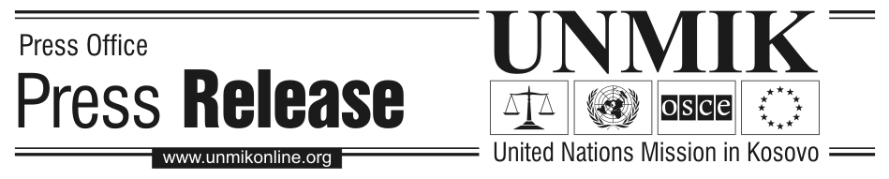

UNMIK/PR/1455
Thursday, 1 December 2005

UNMIK and British Government sign MoU for witness protection system equipment for Kosovo District Courts

PRISTINA – A Memorandum of Understanding was signed today between UNMIK and the British Government for provision of funding by the government of the United Kingdom to UNMIK and the PISG Department of Judicial Administration (DJA) to purchase witness protection system equipment for the five district courts in Kosovo.

The Memorandum was signed by DSRSG for Police and Justice Jean Dussourd and the Deputy Head of the British Office in Pristina Ruairi O’Connell, and was also initialed by the Acting Director of the Department of Judicial Administration.

The funding is aimed at combating the phenomenon of trafficking in human beings in Kosovo by providing equipment to the district courts that will allow victims and witnesses in trafficking cases to testify in a different location from the suspects. The equipment will also allow victims and witnesses to remain anonymous by disguising their voices and facial features. It is hoped that this equipment will reduce the number of occurrences of witness intimidation in trafficking and other serious criminal cases and will make victims and witnesses feel more secure when providing testimony to the courts.

The acquisition of this equipment brings UNMIK and the PISG closer to reaching the standards set out in the Kosovo Standards Implementation Plan, which include the requirement to acquire equipment that will assist in the protection of victims and witnesses during the judicial process.

The successful bidding proposal for the funding was submitted by the UNMIK Department of Justice, in cooperation with DJA, in May of this year. It is anticipated that the tender process for the purchase of the equipment will be completed by the springtime and the equipment will be available to the district courts shortly thereafter.

