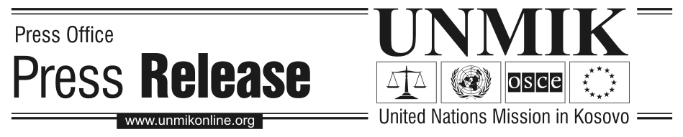
UNMIK/PR/1461
Saturday, 10 December 2005
Kosovo-wide campaign against human trafficking concludes

PRISTINA - UNMIK’s Victim’s Assistance and Advocacy Unit (VAAU) wrapped up the three-week multi-ethnic ‘Not For Sale’ Anti-Trafficking Campaign with a gala concert for youth in Pristina, organised today to coincide with the International Human Rights Day. A series of special films and documentaries will follow on Radio Television Kosovo (RTK) for the rest of the month.

Launched on 18 November 2005, over three weeks the campaign featured regional Youth Day Festivals, the Kosovo-wide School Song Contest and other activities devoted to helping youth of all ethnicities learn about human trafficking, their rights and how to protect themselves. The VAAU also unveiled a new, free telephone ‘HelpLine’ (#044 080 90) for victims of human trafficking that is operational 24 hours a day.

Local NGOs across Kosovo organized activities for youth in the regions of Mitrovicë/Mitrovica, Prizren, Gjakovë/Đakovica, Pejë/Peć, Deçan/Dečani and Gjilan/Gnjilane. The Youth Day Festivals consisted of concerts, sports activities, art exhibits, poetry readings, debates, handouts (notebooks, pens, t-shirts, leaflets and posters all featuring the campaign logo “Not for sale” and the ‘HelpLine’ number) and other activities to inform youth in Kosovo that they are ‘Not For Sale’.

Over 5,000 people from all ethnic communities participated directly in the campaign across Kosovo, which received extensive coverage in the Kosovo media. Schools that won the first three places in the School Song Contest received cash awards of €3,000 (Abdyl Frasheri Elementary School, Prizren), €2,000 (Music School, Mitrovicë/Mitrovica) and €500 (Elementary School Emin Duraku, Gjakovë/Đakovica). The campaign also sponsored a professional basketball tournament with the popular ‘Sigal Pristina’ team whose stars featured in the public service announcements for the campaign.

The Victim’s Assistance and Advocacy Unit (VAAU) was started in UNMIK’s Department of Justice four years ago to safeguard the rights of victims of crimes including trafficking, throughout their involvement with the justice system. Amongst its various activities the VAAU has 23 victim’s advocates across the region who provide direct assistance to victims of trafficking. The VAAU also operates a 24-hour accessible Interim Secure Facility (ISF) for victims of trafficking in human beings. The ISF is responsible for providing safe accommodation and a reflection period to victims of trafficking and presumed victims of trafficking who have been identified through the agreed referral system. The total number of ISF beneficiaries this year is 25.

UNMIK’s VAAU developed this campaign in cooperation with the Kosovo Ministry of Education, Science and Technology, the U.S. Office in Pristina and the OSCE.

