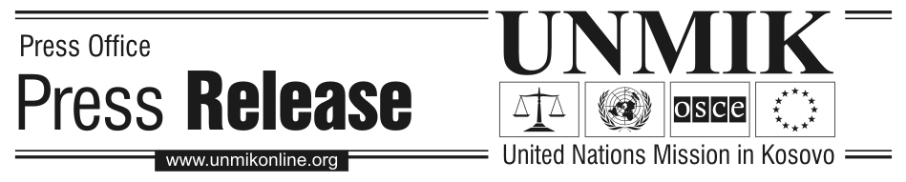

UNMIK/PR/1466
Thursday, 15 December 2005

SRSG meets representatives of the Organisation of War Veterans

PRISTINA – SRSG Søren Jessen-Petersen today met the President of the War Veterans Organisation, Sherif Krasniqi, as well as its Vice-President, Afrim Kuleta, and the President of the Association of KLA Invalids, Faik Fazliu at UNMIK headquarters. They exchanged views on the status process and on the role of the War Veterans.

The SRSG acknowledged the contribution of the War Veterans in bringing Kosovo to this crucial moment. “In particular I thank the War Veterans for the way that they have contributed to managing a stable and secure environment in very difficult circumstances. I realise the pressures that the leaders of the organisation are under since many of the members are obviously frustrated and waiting for clarity on status,” the SRSG said.

The representatives of the War Veterans told the SRSG, among other things, that they want a democratic society where there is full respect for the minorities, because their conflict was never with the minorities but with the regime. “I think these are very important messages that will be heard very loudly and clearly,” the SRSG said.

During the meeting, the SRSG expressed his strong belief that it is obviously in the interest of Kosovo to engage constructively in the status process. “This process has now started and it is clear that now that it has started, it will also be brought to an end and the more the Kosovo delegation engages constructively, the more readiness they show to be involved in the process, the better chances of an early decision which as I’ve said before will clearly take into account the views of the large majority”.

The SRSG appealed to the War Veterans Organisation to continue contributing in the next months to maintaining a stable environment in Kosovo. “I count very much on the constructive role that the War Veterans are playing, with regard to their role and responsibilities in society right now”, the SRSG said.

