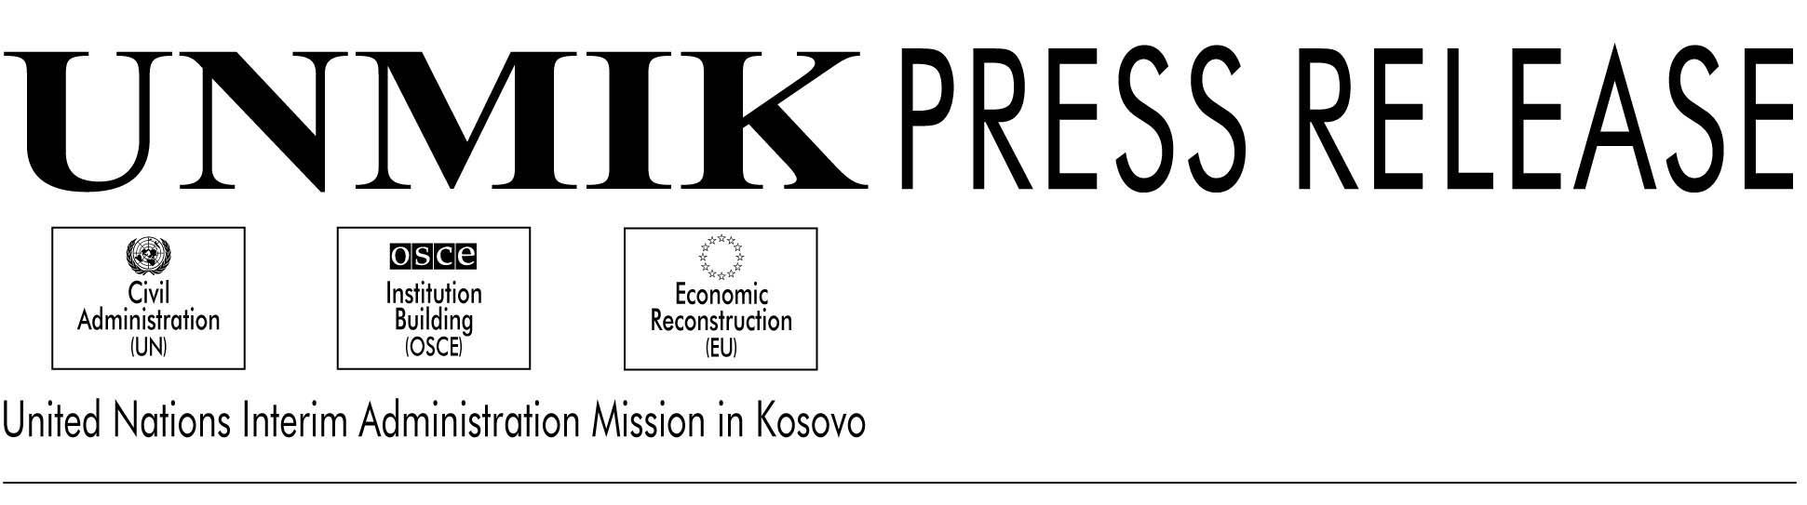

UNMIK/PR/391

16 October 2000

Farmakos, a drug industry in Prizren, will restart its activities

On Saturday, SRSG, Dr. Bernard Kouchner, in his last “outreach initiative”, visited Prizren, a town which he noted managed to keep its long tradition of tolerance, despite the conflict.

The SRSG first addressed the Municipal Council composed of Bosniacs, Turks, Roma and Albanian representatives. While praising them for their multi-ethnic approach and for an election campaign that has been characterized by a strict compliance with the rules of democracy, he reminded his audience about the situation of the Serbs: “They have to come back, not the war criminals, but the ordinary people who used to live here,” Dr. Kouchner said.

In his speech, the President of the Municipal Council, Afrim Arzallazhou thanked UNMIK, which, “by its permanent efforts, is encouraging the local leaders to keep Prizren’s tradition of peaceful coexistence.”

Zenel Kabashi (PNDSH), a member of the Municipal Council, raised the issue of missing persons and detainees. “You are a true leader of Kosovo,” he told the SRSG. “If you have to go to Belgrade to solve this issue, we will support you because we trust you. Only you can do something about it.”

Prizren residents also raised the final status of Kosovo as a pressing matter.

Later, the SRSG inaugurated the new residence for the League of Prizren, an association of intellectuals and politicians created 122 years ago. The former meeting house had been destroyed by Serb forces, few days after the NATO air strike campaign began in March 1999.

The SRSG performed his first wedding in Kosovo within the premises of UNMIK Regional Headquarters. Dr. Kouchner married two UNMIK local staff, Hasan Arzallazhou, a language assistant who interprets for the Turkish representatives in the Kosovo Transitional Council, and his wife, Nazmije Bolloshka, also language assistant.

In the Town Hall meeting in the Cultural Centre, the SRSG reiterated his “pact” with the local population. “Let’s go together to fair, open and democratic elections without violence and then, we will be ready for the next stages--general elections and, eventually self-governance as stated in resolution 1244.”

While some people in the crowd expressed suspicion about the changes in Belgrade, the SRSG replied that one should not wait for change from the outside. “By showing a good example of democracy to the world and to your neighbours, you might give to the latter the willingness to copy your good example.”

He added that while understanding their caution, people of Kosovo should allow President Kostunica some time. “In Belgrade and in Pristina, people must understand that things have changed on both sides for good and that no return to the previous situation is possible or foreseeable.”

The SRSG took also the opportunity to announce long-awaited news: Farmakos, the only drug company in Kosovo, employing 125 persons, has been authorized to restart activities, after having met quality control standards set for the pharmaceutical industry by the World Health Organisation

For information only-not an official record

