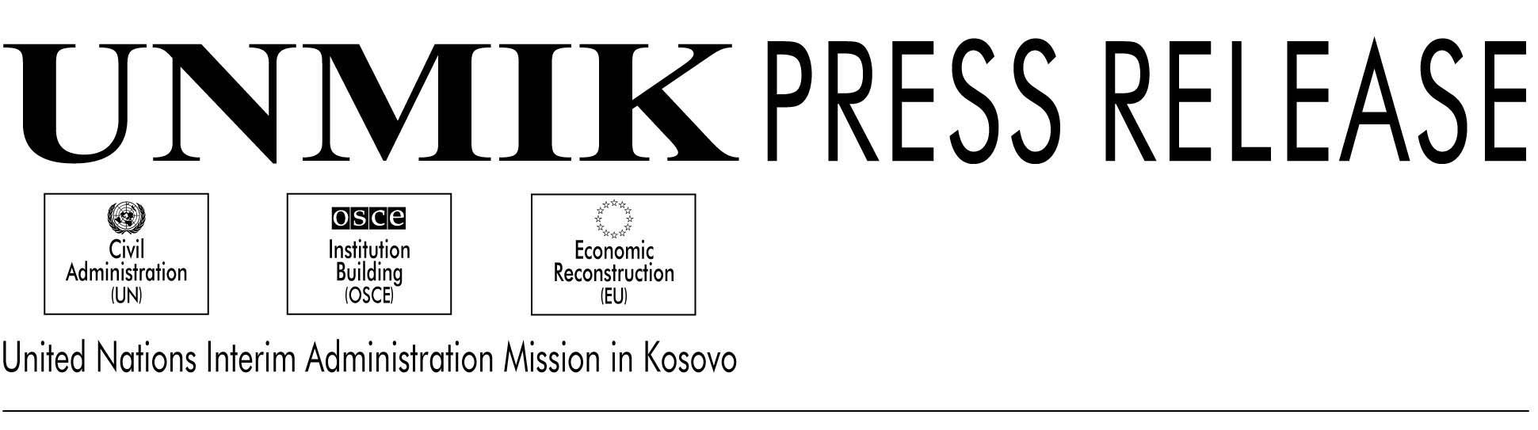

UNMIK/PR/416

15 November 2000

KTC Discusses Albanian Prisoners Issue

PRISTINA---The Kosoto Transitional Council (KTC) today had a detailed discussion on the issue of the Kosovo Albanian prisoners in the Serbian jails and the protests being held in Kosovo seeking their release. The KTC members expressed satisfaction that the demonstrations had been peaceful through Kosovo.

The KTC issued a statement (released separately) on the detained and the missing in which the members appealed to the international community to do its utmost to secure the release of all Kosovar detainees in the Serbian prisons.

The KTC issued yet another statement condemning the murder of the four Ashkalis last week. The statement said: “The members of the Kosovo Transitional Council condemn in the strongest terms the cowardly killing of four members of the Ashkali community. The KTC supports the message of the SRSG to the municipal assemblies that the future of Kosovo lies in tolerance and recognizes the right of Kosovo citizens of all communities to return to their homes in peace and security”.

The KTC was also briefed by the co-heads of the Department of Public Services, Mr. Peter Schumann and Mr. Behxet Brajshori on measures undertaken by UNMIK to build a competent civil service in Kosovo. The co-heads said that the process of establishing contractual arrangements for all staff will be completed by the end of the month. They also said that consultations were ongoing with relevant partners including the OSCE, to work out a training plan for public servants in order to enhance their technical and professional capacities.

The co-heads also answered questions raised by members on delays in payment of salaries to education department personnel that had led to a strike by employees in some parts of Kosovo. They said that due to technical problems, employees had not been paid the last few months. The payroll information coming from schools and other education institutions was incomplete, incorrect, in some cases fraudulent or it simply reached UNMIK late. They added that salaries for September, October and November will be paid from 20 November.

The KTC was also briefed by UNMIK Police on the progress in the investigations into the murder of the four Ashkalis last week.

