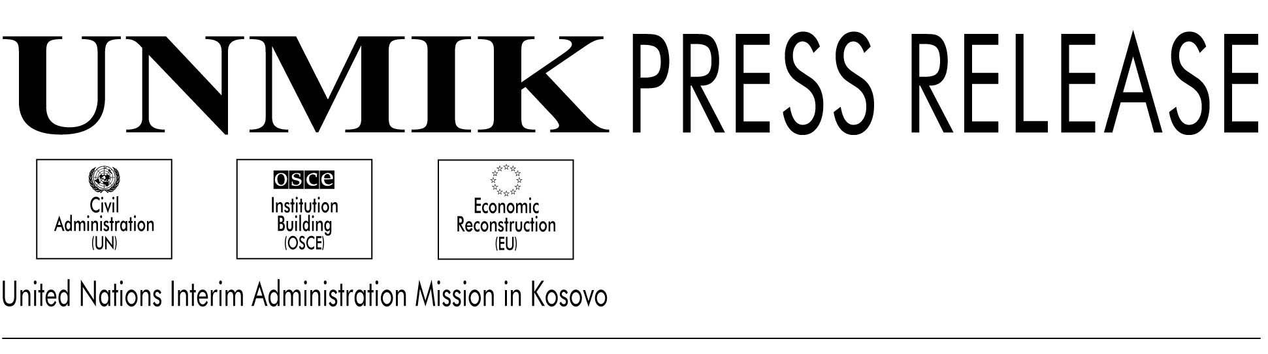

UNMIK/PR/497

16 February 2001

Gary Matthews Appointed New PDSRSG

PRISTINA---Secretary General Kofi Annan has appointed Gary Matthews as the new Principal Deputy to the Special Representative to the Secretary General. He will begin working on 20 February. He replaces former PDSRSG Jock Covey.

Most recently, Mr. Matthews was the Deputy High Representative and Supervisor of Brcko, Bosnia and Herzegovina. Before that he was Director of OSCE’s Regional Centre in Mostar, where he was responsible for the OSCE programmes related to the Dayton Peace Accords in southern Bosnia and Herzegovina. He has been in the Balkans for the last two years.

Mr. Matthews has worked in the US government for 30 years, and has held a series of positions, including, Ambassador to Malta; Special Co-ordinator for the Soviet Union & East Europe; and Acting Assistant Secretary of State.

He did active service for the U.S. Army in Germany in 1955-1958, and served as a captain in Vietnam from 1971-1973, where he received the Cross of Gallantry with Bronze Star. He has held various other positions in the U.S. government, and has had foreign assignments in Germany, Poland, and Russia, in addition to Vietnam and Malta.

Gary Matthews graduated from Drury College in 1960 with a Bachelor of Arts in History. The following year he received his M.A. in Political Science from Oklahoma State University, and in 1969 he graduated with an M.A. in International Affairs from Columbia University.

SRSG Hans Haekkerup has welcomed the appointment of Mr. Matthews.

