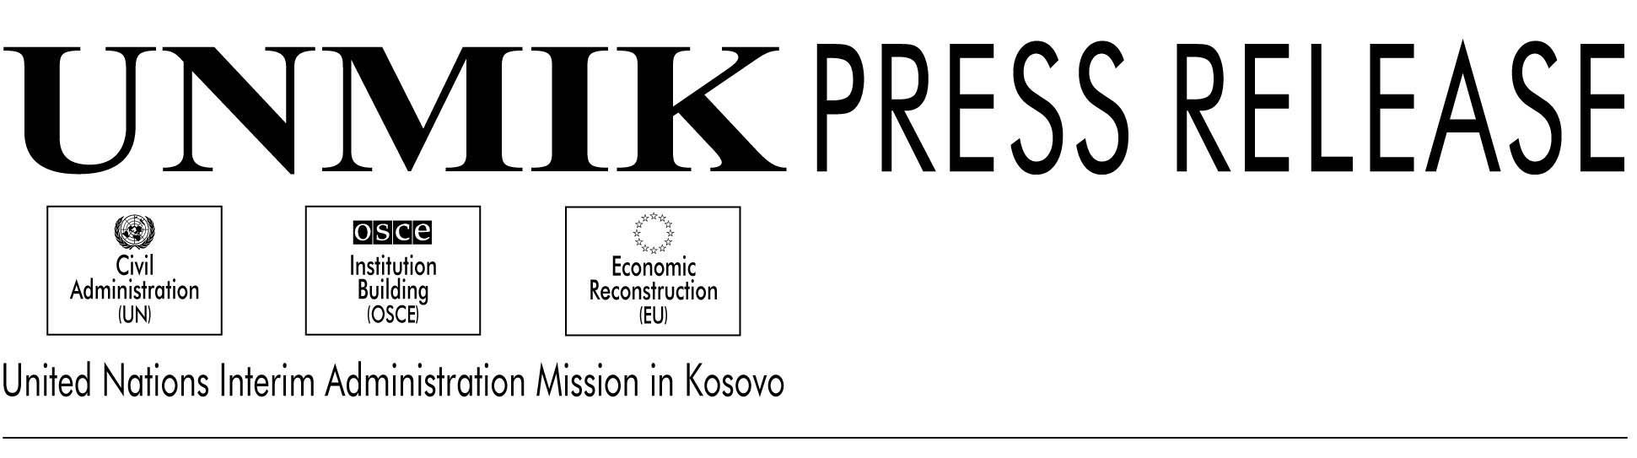

6

UNMIK/PR/499

16 February 2001
17 February 2001

United Nations Security Council condemns attack on Kosovo bus

The President of the United Nations Security Council, with the agreement of the Council members, issued the following statement yesterday on the attack against the bus convoy near Merdare.

New York—“Members of the Security Council expressed their shock at, and strongly condemned, the terrorist attack on a convoy of buses carrying Kosovo Serb civilians at Merdare, as well as other attacks and acts of violence committed in Kosovo. This latest tragedy follows a recent upsurge in violence in Kosovo, which is totally unacceptable and must be reversed.

Members of the Council called for an immediate and full investigation to bring the perpetrators to justice.

Members of the Council emphasized the importance of redoubled efforts by KFOR and UNMIK to prevent further attacks and they expressed concern for the personnel of UNMIK and KFOR whose lives were endangered by this attack.

Members of the Council appealed for calm and called on all inhabitants of Kosovo to stand against the violence of extremists working against peace and stability. They called again on Kosovo’s political leaders to contribute to the stability of the situation, and to cooperate fully with UNMIK in building a safe and prosperous, multi-ethnic Kosovo.

Members of the Council expressed their intention to follow the matter closely.”

