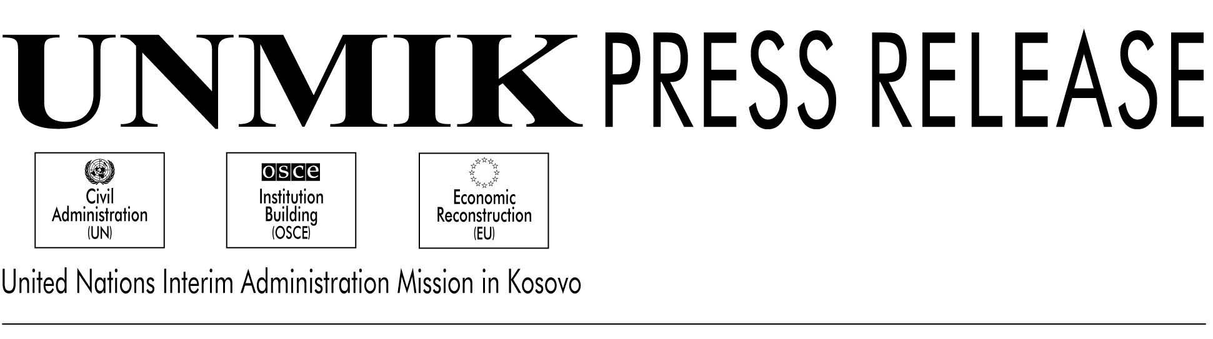

UNMIK/PR/512

27 February 2001

Matthews Welcomes Haradinaj to IAC; Health Care Discussed

PRISTINA---PDSRSG Gary Matthews, leading the Interim Administrative Council today in the absence of SRSG Hans Haekkerup, welcomed the arrival of Mr. Ramush Haradinaj, whom the SRSG appointed to fill the fourth Kosovo seat on the IAC.

“A complete IAC membership is necessary for the important work that lies ahead of us, not least the negotiations on the legal framework,” Mr. Matthews said.

Mr. Matthews told the IAC that the SRSG would reconstitute the joint working group on the legal framework on 6 March.

He said that Mr. Haekkerup would address the North Atlantic Council tomorrow in Brussels with the message that the “international community will need to maintain and continue to assert an active role in Kosovo.”

Mr. Matthews also noted that Mr. Haekkerup had met on Friday with FRY President Vojslav Kostunica and FRY Foreign Minister Goran Svilanovic in Skopje, on the margins of the Balkans summit. The SRSG passed on messages from Kosovo Albanian IAC members, which stressed the importance of releasing Kosovo Albanian detainees, resolving the division of Mitrovica and encouraging Kosovo Serb cooperation with UNMIK.

KFOR Commander General Carlo Cabigiosu, in his security update, said that while snow had stilled the military activity recently in the Presevo Valley, the diplomatic activity had increased, and steps were being taken toward starting talks between ethnic Albanians and FRY and Serb authorities. KFOR is also “establishing closer control” over the Kosovo-FYROM border, he said, where some tension just inside FYROM has been noted.

The co-heads of the Department of Health and Social Welfare –Hanna Vuori and Pleurat Sedjiu--delivered a comprehensive report on the state of Kosovo’s health care system. The Department’s 35 staff (including four internationals and 31 Kosovars) oversees five regional hospitals and many health houses, with a budget of 104 million DM. Of this, 92 million DM derives from the Kosovo Consolidated Budget and 12 million DM from user fees.

The state of Kosovo’s health remains the poorest in Europe, after the country of Albania. Particular problems here lie with reproductive health, endemic infectious diseases, environmental pollution and post-traumatic stress syndromes.

The heath care system which the Department inherited is physically run-down and structurally top-heavy, with little attention to preventative medicine. There is a shortage of skilled nurses and managers, along with a relative abundance of administrative staff.

The UNMIK Department of Health has been faced with the choice of whether to restore what existed or create an entirely new system.

The administrative Department of Health and Social Welfare has as its goals the creation of an equitable, non-discriminatory, effective, high-quality, accessible and sustainable system.

The Department is concentrating on improving the health of young people, improving mental health, developing skilled human resources and reducing communicable diseases.

The guiding philosophy is to deliver public health via a mix of public and private services using family medicine as the basic methodology.

The Department so far has established a legal framework, an overall policy and norms and standards for the Kosovo health system. It has been rehabilitating the infrastructure and developing human resources, with specialists now allocated around Kosovo and licenses to all health workers. Advanced training has been arranged elsewhere in Europe. One of the Department’s priorities is to establish cardiovascular and oncological specialties here, but this will take up to two years to develop, according to Sedjiu.

Finally a copy of a draft regulation which would establish a Kosovo Judicial Council was distributed to IAC members and will be discussed at the next IAC meeting.

