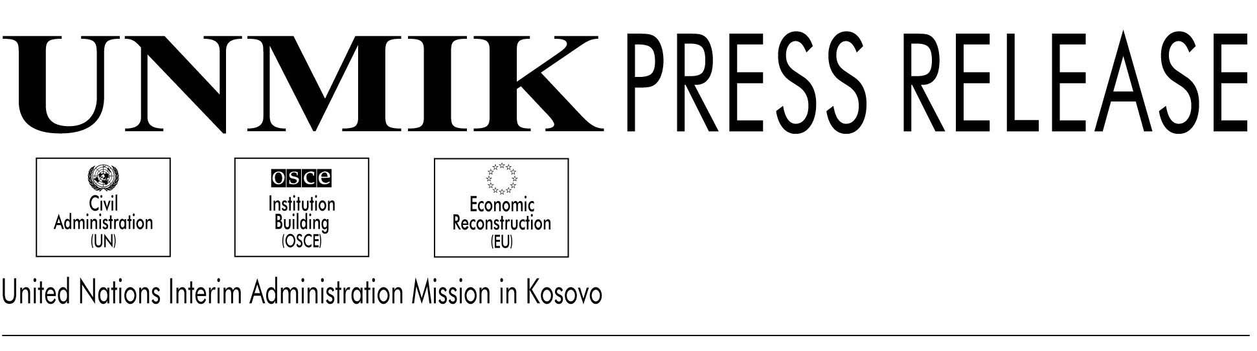

UNMIK/PR/583

21 May 2001

PDSRSG Announces New Police & Justice Pillar

PRISTINA -- UNMIK announced today the formation of a new structure that will join the UNMIK departments of law enforcement and judicial affairs in order to strengthen the fight against crime.

The two departments, which had been part of UNMIK’s Pillar II, Civil Administration, will now be united into a single Pillar I, “Police and Justice”. (For the first year of UNMIK’s mandate, Pillar I was dedicated to Humanitarian Assistance.)

Gary Matthews, the Principal Deputy Special Representative of the Secretary General, who will head the new pillar, described the new Pillar in a press conference today. “This new structure reflects the commitment of SRSG Hans Haekkerup to strengthening the law enforcement and criminal justice systems in Kosovo,” said Matthews.

The SRSG’s objective in bringing these police, security and justice functions into the new, distinct pillar is to provide greater focus, centrality and coordination of efforts, Matthews said. As before, the UNMIK Police and the Department of Judicial Affairs will be the major components of these efforts.

The establishment of Pillar I comes just one week after the promulgation of the Constitutional Framework for Provisional Self-Government. It is therefore particularly appropriate that the new police and justice pillar be established at this time, Matthews said.

“The people of Kosovo want a peaceful and productive life for themselves and their children. They want an end to violence,” said Matthews. “They want to be part of a peaceful and prosperous region. They do not want fear and intimidation by organized crime, criminals and terrorists.

The priorities of Pillar I include an increase in the number of KPS officers, judges and prosecutors throughout Kosovo and the expansion of detention and penal facilities to hold those convicted of crimes. Additionally there will soon be greater resources and legislative powers to deal with crime, terrorism and violence. Included are the 4 June legislation to deal with illegal weapons possession, with especially heavy penalties for weapons trafficking, legislation to deal with illegal border/boundary crossings and legislation to deal with those who engage in terrorist-related activities.

“All of this is about improving the life of the people and children of Kosovo. They want a future based on democratic values, peaceful circumstances, the rule of law,” said Matthews. “The new Constitutional Framework and the elections in November will light the way. So,
too, will our highly concentrated efforts on police, security and justice issues as I now begin to implement initiatives and programs within the new Police and Justice Pillar.”

