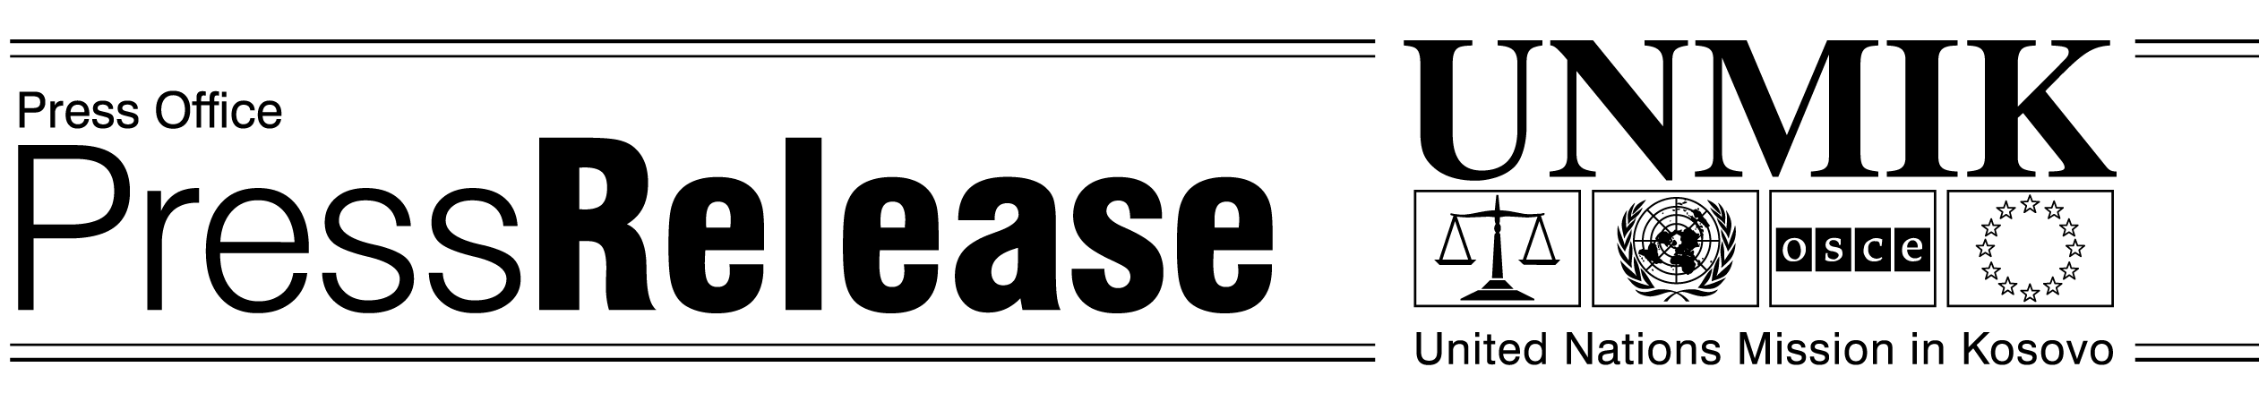
UNMIK/PR/696
Wednesday, 27 February 2002

Conference on Market Economy Legislation
Opening Remarks by SRSG Michael Steiner

Good Morning,

I am very happy to be here today together with President Daci, to open this conference on “Market Economy Legislation”.

I have made it one of my key goals to help stimulate economic growth. Kosovo needs investment and jobs.

If you ask the people here in Kosovo about their number one concern, I am sure that, apart from security, most will point to the economy. The economy is in a very difficult position. Imports account for 80 percent of domestic consumption, and there are virtually no exports. Some 50 percent of the work force is unemployed. In order to survive, people in Kosovo currently rely on transfers from relatives working abroad and on foreign donations.

The construction boom that you can see if you travel around Kosovo is also based on remittances from abroad. But there is hardly any private investment in productive enterprises and activities which can generate jobs.

***

At the same time, there is money here to be invested. In the process of Euro conversion, people in Kosovo are exchanging roughly two billion German marks for Euro. This money is coming out from under their mattresses.
Unfortunately, instead of being invested, some two thirds of it immediately disappears back underneath those same mattresses after being converted. If the people of Kosovo are not brave enough to invest in their own future, how can we expect anyone else to put their money here?

Let me make it very clear. The inability and, in some cases, unwillingness to form so far a government based on the results of the first fair and free general elections in Kosovo has had a most detrimental effect. Not only has Kosovo’s image abroad suffered greatly. There is also a deep mistrust by the people of Kosovo in their institutions. Who would invest in a territory where there is no government?

That is why we need to move now!

***

Ladies and Gentlemen,

The development of the private sector requires an orientation towards a market economy and a society based on the rule of law.

The absence of a coherent commercial and economic legal framework constitutes a major barrier to investment. Investment requires legal certainty: enforceable legal claims and clear property ownership. Without clarity in property title, private entrepreneurs are unable to take out loans against their immovable property – and therefore cannot raise the capital necessary for starting up or expanding their business activities.

Another barrier to investment is the unfair competition that the private sector faces from the socialist-inherited industries. Where socially-owned enterprises have free use of business premises, the private sector has to pay disproportionately large rental costs for shops, offices and warehouses. While private businesses often have to pay for laying their own electricity, water and telephone lines, socially-owned enterprises rarely even pay their bills. It is important to harden the budget constraints on these companies. Bankruptcy proceedings will have to be initiated against those companies whose debts exceed the value of their assets and output.
***

Ladies and Gentlemen,

Certain economic and commercial legal subject areas are now within the authority of the Provisional Institutions of Self-Government (or PISG), while others remain under UNMIK. But there can be only one economy in Kosovo. This economy requires a coherent and internally consistent system of commercial and economic law. In order to support economic and private sector development, close coordination between UNMIK and the PISG in planning and preparing legislation is vital.

For this reason, I warmly welcome the recommendations of the expert group, to be presented this afternoon, which will form the basis of the expert discussions tomorrow.

As I understand, the purpose of those recommendations is to assist both UNMIK and the PISG in identifying priority areas of legislative activity, and to provide to both UNMIK and the PISG recommendations that will be useful in drafting the concerned laws and regulations.

***

Finally, I would like to emphasise that Kosovo can only hope to achieve economic prosperity within the context of economic coordination and integration, both regionally and with the European Union.

As part of the Stabilisation and Association process, all of the countries in the region are now moving their legislative frameworks in the same general direction: towards consistency with EU norms and international standards. As the various legal systems in the region are being modified to harmonise them with European and international standards, they are also brought into greater harmony with their neighbours. European integration and regional integration are thus two sides of the same coin that complement each other. This can only serve to increase regional economic trade and investment.

The importance of the European and regional context in the economic development of Kosovo is why I whole-heartedly welcome the presence of Reinhard Priebe who represents the EU Commission. UNMIK, the European Union and the Stability Pact will work together in seeking to attract jobs and investment to Kosovo.

