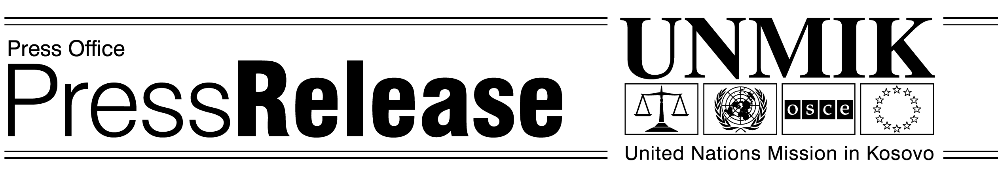
UNMIK/PR/741
Sunday, 26 May 2002

Six Serbian Prisoners transferred to FRY Detention Facilities

On 26 May 2002, six prisoners of Serbian ethnicity were transferred from Mitrovica Detention Center to detention facilities in the Federal Republic of Yugoslavia, outside Kosovo. These transfers are pursuant to the Agreement on the Transfer of Sentenced Persons between UNMIK and the Federal Republic of Yugoslavia signed on 3 April 2002. Under the terms of the Agreement, sentenced prisoners -- either in Kosovo under UNMIK custody or in the FRY -- may express interest in being transferred. Each of the six prisoners being transferred from Mitrovica expressed interest in being relocated to facilities in the FRY.

The Ministry of Justice of the Republic of Serbia requested the transfer of these six prisoners, all of whom fulfill the criteria for transfer under the Agreement. One of the prisoners was convicted for intermediation in the exercise of prostitution and sentenced to 6 months and 18 days. Four prisoners were convicted for murder and received sentences ranging from 11 years to 15 years. The sixth prisoner was convicted of war crimes and sentenced to 20 years imprisonment. These judgments remain in force after transfer.

UNMIK and the Federal Republic of Yugoslavia have agreed to transfer these prisoners to detention facilities in the FRY on humanitarian grounds. The Agreement was modeled on the European Convention on the Transfer of Sentenced Persons (1983) which established the practice in Europe that defendants convicted and sentenced by courts in foreign jurisdictions could serve their sentences in facilities within their home jurisdictions. Under the Agreement, the six prisoners to be transferred from Mitrovica Detention Center have similar rights as prisoners in other parts of Europe. They will be relocated to detention facilities in the FRY where they are closer to their homes and where family can visit them more easily.

The transfer to the FRY does not affect the sentences of the six prisoners. According to the Agreement, the FRY and the Republic of Serbia will continue the enforcement of the sentences and are bound by the legal nature and duration of sentences issued by the UNMIK justice system.

