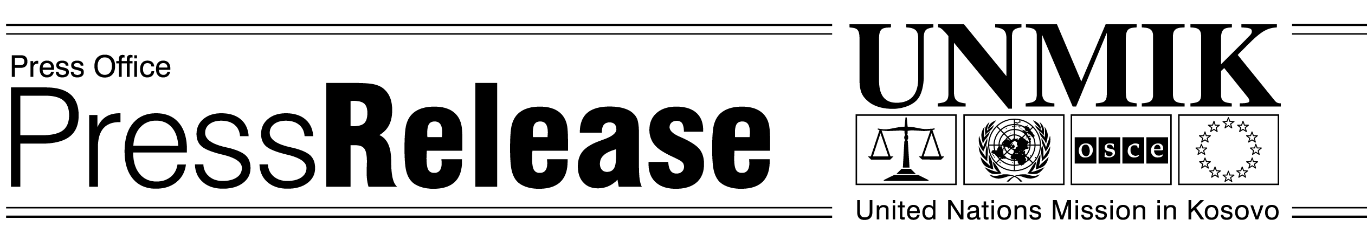
UNMIK/PR/758
Wednesday 19 June, 02

UNMIK SRSG Michael Steiner
Remarks to South Eastern European Cooperation Process

BELGRADE-Mr. Chairman I am very happy to be here in Belgrade and would like to congratulate you for your excellent organisation and hospitality.

We just passed the three year anniversary of UNMIK’s and KFOR’s arrival in Kosovo. We marked this with the swearing in of the democratically elected, now completed, multiethnic government.

The goal of UNMIK and this government is to help Kosovo become a part of an integrated Europe. This is the goal we all share. Like every delegation here today, we recognize that to achieve this goal we need to meet certain criteria.

When I last spoke to the Security Council I laid out a process of benchmarks or standards to measure progress toward meeting these criteria. These benchmarks were strongly endorsed by the Security Council, the International Community at-large and by Kosovo’s Provisional Institutions.

These standards represent the cornerstones of future progress and include:

- creating functioning democratic institutions
- institutionalizing the rule of law
- freedom of movement for everyone everywhere
- return and integration of displaced people
- regenerating Kosovo’s economy
- property rights

These benchmarks are the prerequisites that must be met before discussions can take place on final status - and they are the vehicle that will carry Kosovo toward Europe This is why I say standards before status And achieving them is an end in itself - actively contributing to regional stability

Today UNMIK is representing Kosovo. But we hope that in the next meeting representatives of the Provisional Government will be included in my delegation. Many of the issues discussed at today’s summit involve the transferred responsibilities that are the domain of the Provisional institutions. Local leadership must become involved in the regional dialogue.

There is much potential for dialogue, cooperation and progress in the economy, and in particular in the energy and telecommunications sectors, and in combating organized crime

Let’s look, for example, at energy: The markets for energy of each country individually are not large enough to make major infrastructure investments profitable.

Let’s learn from the European method: The European Coal and Steel Community succeeded as a regional initiative because it developed an institutional framework of cooperation in a concrete area in which all participating states had a common interest.

Energy policy is one of the fundamentals of prosperity for the peoples of South Eastern Europe. The lack of regional cooperation in the trade and regulation of energy brings both high costs and risks to stability. The destabilizing potential of energy shortages has been apparent in Serbia, in Montenegro, in Kosovo and in Albania and elsewhere.

An integrated electricity market would be a ‘grand project’ worthy of the European aspirations of all the countries present here. It can contribute to regional security, as well as producing opportunities for region-wide economic growth.

There are many political obstacles to resolve to make such an integrated energy market a reality. But the benefits far outweigh the difficulties. Thus a regional energy vision is worthy of the attention of this forum and I commend it to you.

Now, organised crime which is so often mentioned: Energy and telecommunications notwithstanding, it is in the area of organized crime and corruption that I want to concentrate today.

I have declared a policy of Zero Tolerance for Crime - UNMIK Police proved in Pec/Peja yesterday with a number of arrests, that we mean it. And there is more to come. Much is already covered by initiatives like the Stability Pact, but SEECP can make a difference as its initiatives are born of the region. Crime exported from our region worries European leaders. Corruption and organized crime must be tackled robustly if we want to be taken seriously by Europe.

Some mechanisms exist already - INTERPOL, bilateral agreements and informal cooperation. UNMIK recently signed agreements on police cooperation with the FRY and Serbian Governments. We are also working on similar agreements with Montenegro, fYROM and Albania

All this, though good, is not enough: We need a broad, cooperative approach to fight terrorism, money laundering, organized crime and trafficking.

As we always say, these activities know no borders and must be treated regionally. Organised criminals practice more internationalism than we do. Let’s learn from organized crime! Let’s also learn from Europe. Europe has an agreement on police and justice cooperation, overseen by new regional cooperation units. We, in the SEECP should do the same.

There is Europol and Eurojust. Why not Balkanpol or SEEPol and Balkanjust or SEEJust?

Balkanpol or (SEEPol) would need:

- pan-regional intelligence to assess trends and build up understanding of organized criminal networks;
- Information-sharing between police and customs authorities;
- Coordination of operations such as support to joint investigative teams drawn from across the region.

It would also need improved police cooperation to:

- prosecute criminals at home for crimes committed abroad;
- imprison criminals at home who have been duly convicted abroad;
- facilitate the collection of evidence and interrogation of witnesses located in other states;
- increase the effectiveness of international arrest warrants and extradition procedures,

Furthermore to:

- align the criminal laws and practices in the region, particularly in the areas of financial crime and trafficking;
- And to identify, freeze and confiscate proceeds of crime located in other states.

Similarly, Balkanjust or (SEEJust) would oversee and facilitate judicial cooperation and could also facilitate coordination between prosecutors in organized crime cases.

But structures alone are not enough. We need to empower public opinion and civil society. We need more public participation. The average citizen must take ownership in the values to which we all aspire: public accountability, public ethics and transparent government And this brings me back to the benchmarks.

The benchmarks are not just for government, but are for the people. They need to take possession of the concepts behind the benchmarks. As they are achieved, the institutions will function, the rule of law will be upheld, people will move freely returning to their homes and property - and society will become more prosperous as the economy improves.

In my speech in Tirana, I said we needed to bring pride back to the word Balkan. Exactly as expressed today by Mircea Geoana when he spoke of rebranding the Balkans. When we achieve these benchmarks and standards in the region, this pride will have returned.

